# Installing Python on Windows

**Step 1: Select Version to Install Python**

Visit the official page for Python <https://www.python.org/downloads/> on the Windows operating system. Locate a reliable version of Python 3, preferably version 3.10.11, which was used in testing this tutorial. Choose the correct link for your device from the options provided: either **Windows installer (64-bit) or Windows installer (32-bit)**and proceed to download the executable file.

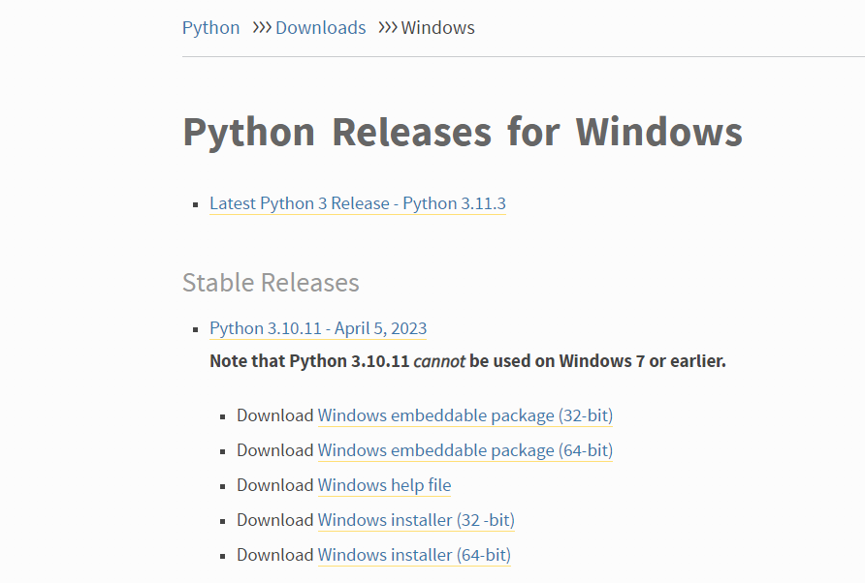

**Step 2: Downloading the Python Installer**

Once you have downloaded the installer, open the .exe file, such as p**ython-3.10.11-amd64.exe**, by double-clicking it to launch the Python installer. Choose the option to Install the launcher for all users by checking the corresponding checkbox, so that all users of the computer can access the Python launcher application. Enable users to run Python from the command line by checking the Add python.exe to PATH checkbox.

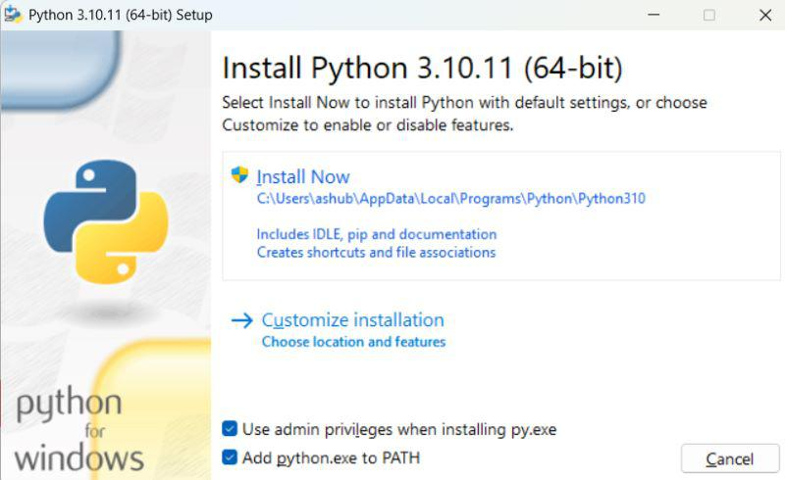

After Clicking the **Install Now Button** the setup will start installing Python on your Windows system. You will see a window like this.

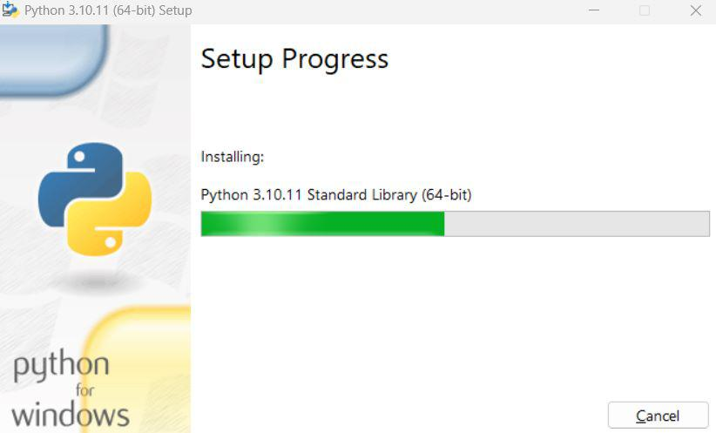

**Step 3: Running the Executable Installer**

After completing the setup. Python will be installed on your Windows system. You will see a successful message.

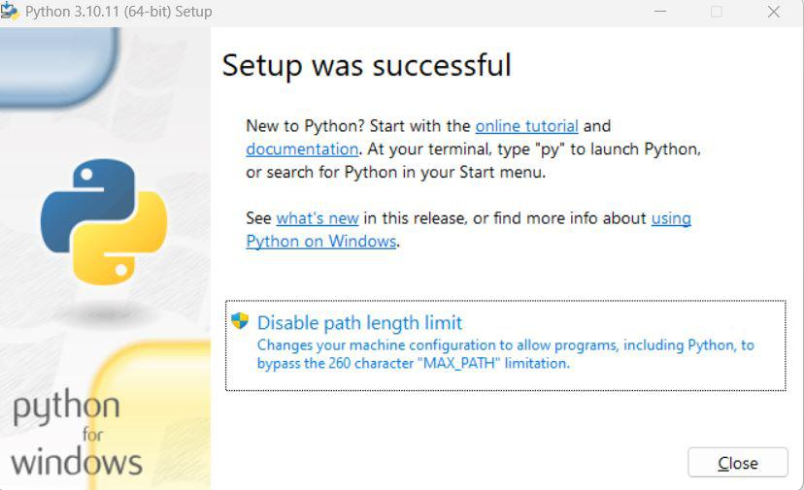

# Basics of Python Programming

The classic first program in any language:

